UNITED STATES

SECURITIES AND EXCHANGE COMMISSION

Washington, D.C. 20549

SCHEDULE 14A

(Rule 14a-101)

INFORMATION REQUIRED IN PROXY STATEMENT

SCHEDULE 14A INFORMATION

Proxy Statement Pursuant to Section 14(a) of the Securities Exchange Act of 1934

(Amendment No. )

Filed by the Registrant ☐

Filed by a Party other than the Registrant ☒

Check the appropriate box:

- Preliminary Proxy Statement

- Confidential, for Use of the Commission Only (as permitted by Rule 14a-6(e)(2))

- Definitive Proxy Statement

- Definitive Additional Materials

- Soliciting Material Under § 240.14a-12

VAXART, INC

(Name of Registrant as Specified In Its Charter)

DANIEL P. HOULE
MARK SILVERBERG, DDS, MD
MATTHEW M. WALLACE, MD
PATRICE RAFFY
Q3 NOMINEES PTY LTD

MARC EUSTACE PEREIRA
(Name of Persons(s) Filing Proxy Statement, if other than the Registrant)

Payment of Filing Fee (Check all boxes that apply):

- No fee required

- Fee paid previously with preliminary materials

- Fee computed on table in exhibit required by Item 25(b) per Exchange Act Rules 14a-6(i)(1) and 0-11

Daniel P. Houle and the other participants named herein (collectively, the “Concerned Vaxart Stockholders”) have filed a definitive proxy statement and accompanying GOLD universal proxy card with the Securities and Exchange Commission to be used to solicit votes for the election of the Concerned Vaxart Stockholders’ slate of director nominees at the 2026 annual meeting of stockholders (the “Annual Meeting”) of Vaxart, Inc., a Delaware corporation (the “Company”).

Item 1: On June 6, 2026, Daniel P. Houle posted the following message on Stocktwits. Mr. Houle reposted the message on Stocktwits on June 7, 2026 and he anticipates reposting it daily on Stocktwits through the date of the Annual Meeting.
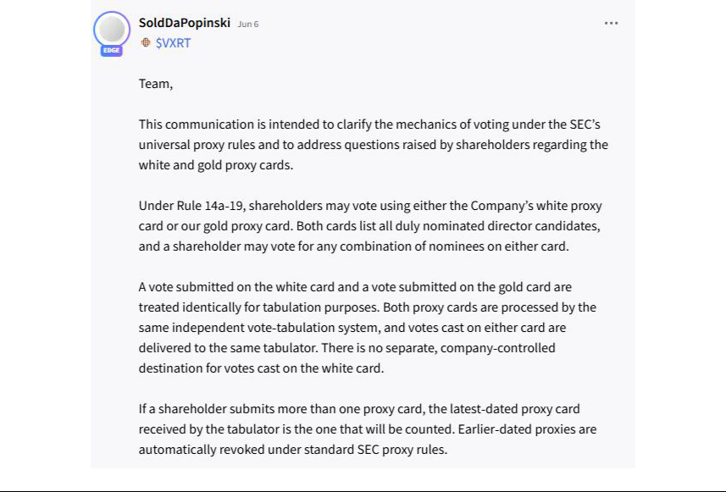

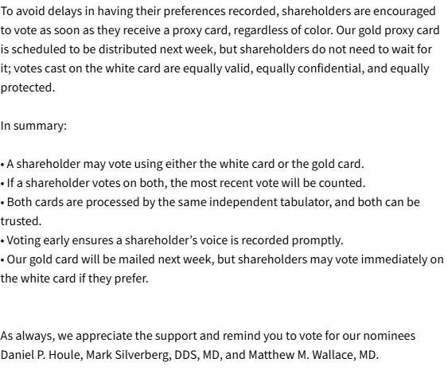

Item 2: On June 8, 2026, the following letter is being mailed to stockholders of the Company by the Concerned Vaxart Stockholders, a copy of which is also attached hereto as Exhibit 1 and is incorporated herein by reference.

THE CONCERNED VAXART STOCKHOLDERS

A coaliton of retail investors owning 1,515,343 shares of Vaxart, Inc. (OTCQX: VXRT)

YOUR VAXART INVESTMENT IS DOWN 91% — THE BOARD MUST CHANGE

VOTE THE GOLD UNIVERSAL PROXY CARD — FOR HOULE, SILVERBERG AND WALLACE

Dear Fellow Vaxart Stockholder:

We are the Concerned Vaxart Stockholders — a coaliton of dedicated retail investors who, like you, believed in the promise of Vaxart, Inc. (“Vaxart” or the “Company”) and entrusted our hard-earned capital to its leadership. Together, we own 1,515,343 shares of common stock. We are not a hedge fund. We are not Wall Street insiders. We are stockholders who have watched, with growing alarm, as the incumbent Board and management team presided over staggering losses, diluted us at fre-sale prices on the very day they received transformatonal government funding, kept us in the dark about a director under federal insider-trading investgaton, and twice tried to ram through a reverse stock split that stockholders soundly rejected.

Enough is enough. At the 2026 Annual Meetng on July 16, 2026, you have the opportunity to demand accountability and elect three independent, stockholder-aligned directors — Daniel P. Houle, Mark Silverberg, DDS, MD, and Mathew M. Wallace, MD — who will fnally bring the voice of retail investors into the Vaxart boardroom.

91% LOST. $343 MILLION BURNED. THE NUMBERS DON’T LIE.
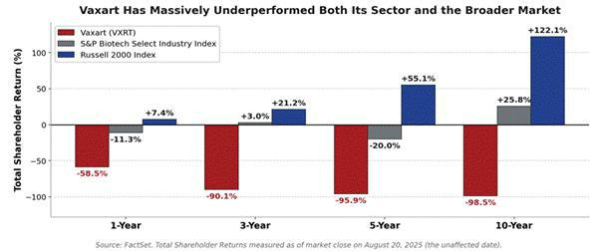

Source: FactSet. TSR measured to market close on August 20, 2025 — the trading day before our coaliton frst publicly demanded boardroom accountability.

Five Years of Underperformance — On Every Measure That Maters

The numbers are not in dispute. Over the past fve years, Vaxart’s share price has collapsed by more than 91%,¹ and the Company has accumulated
approximately $343 million in losses since 2020.² Measured from the unafected date of August 20, 2025 — the last trading day before our coaliton frst publicly demanded change — Vaxart has lagged the S&P Biotechnology Select Industry Index by 47.2% over one year, 93.1% over three years, and a staggering 124.3% over ten years. Against the broader Russell 2000, Vaxart has trailed by 220.6% over a decade. These are not the results of a difcult market. They are the results of a Board and management team that has failed at its most basic job: creatng value for its owners.

¹Source: FactSet. Calculated as of market close on May 20, 2026.
²Source: Vaxart, Inc. Form 10-K flings (cumulatve accumulated losses since 2020).

While stockholders watched their investment evaporate, the Board rewarded the incumbents with contnued seats and named-executve-ofcer compensaton that, at the 2025 Annual Meetng, stockholders overwhelmingly voted against on the advisory say-on-pay proposal. That message was ignored. We urge you to send it again — louder – by electng our three candidates Daniel P. Houle, Mark Silverberg, DDS, MD, and Mathew M. Wallace, MD.

They Got a $453 Million Lifeline — Then Diluted You Within Hours

If you want a single moment that captures why this Board cannot be trusted with your capital, consider the events of June 13, 2024 — a day that should have been the best day in Vaxart’s history, but instead became a textbook case of value destructon by management:

- 4:00 p.m. ET — Vaxart common stock closes at $0.75 per share.

- 4:15 p.m. ET — Vaxart announces a project award valued at up to $453 million through the BARDA-funded Rapid Response Partnership Vehicle to run a Phase 2b study of its oral pill COVID-19 vaccine — with $65.7 million available immediately.

- 7:07 p.m. ET (same day) — Vaxart announces an underwriten ofering of 50,000,000 shares of common stock at just $0.80 per share — less than three hours afer disclosing one of the largest BARDA awards to date.

Read that sequence again. The Company received transformatonal, non-dilutve government funding — and three hours later, before the market could even price in the news, the Board issued 50 million new shares at a price barely above the prior closing price. Stockholders never got the chance to beneft from the BARDA announcement. Management captured the headline; existng stockholders absorbed the diluton. A Board with even a basic sense of stewardship would have considered the non-dilutve funding, let the market reprice the stock, and protected existng owners. This Board did the opposite.

They Hid From You That a Director Was Under Federal Insider-Trading Investgaton

In November 2024, FBI agents approached then-director Robert A. Yedid as part of an insider-trading investgaton alleging that, from 2019 to 2024, Mr. Yedid partcipated in a scheme to provide friends with inside informaton about several healthcare-company clients of the investor-relatons frm where he was employed. We believe the Board knew. Stockholders did not.

On January 28, 2025, the Company simply announced that Mr. Yedid had resigned “for personal reasons” and thanked him “for his years of service and contributons to our Company.” No menton of the FBI. No menton of the federal investgaton. No menton of the allegatons that had been brought to a sitng Vaxart director’s atenton more than two months earlier.

On June 6, 2025, Mr. Yedid pled guilty to the alleged insider-trading scheme. The Concerned Vaxart Stockholders have no reason to believe the conduct related to Vaxart securites — but that is not the point. A Board that chooses a fatering farewell press release over candid disclosure to its own stockholders has lost the right to ask for your contnued trust.

While You Lost, They Cashed In — Over $5.2 Million in Executve Pay in a Single Year

There is one group that has done remarkably well at Vaxart while stockholders have lost over 91% of their investment: the executves running it. According to the Company’s own 2026 proxy statement, Vaxart paid its three named executve ofcers more than $5.2 million in total compensaton for fscal year 2025 alone — the bulk of it in stock and opton grants priced at or near the Company’s collapsing share price. CEO Steven Lo’s pay jumped roughly 35% year-over-year to $2.8 million:

Named Executve Ofcer | Salary | Stock Awards | Opton Awards | TOTAL
Steven Lo — President & CEO | $650,000 | $776,203 | $964,910 | $2,810,918
James Cummings, M.D. — CMO | $521,000 | $208,116 | $302,106 | $1,254,494
Sean Tucker, Ph.D. — CSO | $465,000 | $208,116 | $279,220 | $1,144,358
TOTAL — 3 Named Executve Ofcers | $1,636,000 | $1,192,435 | $1,546,236 | $5,209,770
Source: Vaxart 2026 Defnitve Proxy Statement, 2025 Summary Compensaton Table. Salary, Stock Awards, Opton Awards columns shown; TOTAL also includes Non-Equity Incentve Plan Compensaton and All Other Compensaton.

Just look at the equity grants. On March 24, 2025 — with the stock trading at just $0.5126 — the Board handed CEO Steven Lo optons to purchase 2,108,000 shares plus 1,405,000 restricted stock units (“RSUs”). On the same date, Chief Medical Ofcer Dr. Cummings received 660,000 optons (including a 50,000-share “spot bonus”) plus 406,000 RSUs, and Chief Scientfc Ofcer Dr. Tucker received 610,000 optons plus 406,000 RSUs. Mr. Lo was also awarded an

additonal 151,351 RSUs as a separate spot bonus.³ The strike prices on management’s outstanding optons — $0.5126, $0.78, $1.16 — refect a stock that has been beaten down by years of underperformance.⁴ The lower the share price falls, the cheaper the optons become for management. The same diluton and value destructon that has cost you is funding their wealth creaton.

And when stockholders objected — votng overwhelmingly AGAINST the advisory say-on-pay proposal at the 2025 Annual Meetng — the Board ignored you and approved the next round of grants anyway.

They Lost the Reverse-Split Vote — Then Tried to Force It Through Anyway

When stockholders rejected the Inital Reverse Stock Split Proposal at the 2025 Annual Meetng with a clear 59.1% majority votng AGAINST, the Board’s response was not to listen — it was to try again. Barely a month later, the Board called a Special Meetng to push an Additonal Reverse Stock Split Proposal, before ultmately withdrawing it in the face of mountng stockholder oppositon organized by our coaliton. At the same 2025 Annual Meetng, four of the six directors — including then-Chairman Michael Finney — failed to receive majority support, kept in their seats only by a plurality votng standard. And afer we nominated three independent directors, the Board unilaterally appointed a new director without stockholder input — without taking the tme to so much as interview any of our nominees or try to work together to fnd any mutually agreeable candidates.

³Source: Vaxart, Inc. Defnitve Proxy Statement (DEFC 14A), fled June 1, 2026, 2025 Summary Compensaton Table and Outstanding Equity Awards as of December 31, 2025.
- Dr. Cummings and Dr. Tucker also have older optons at higher strike prices.

The patern is unmistakable: lose a vote, ignore the vote, try again. Reject stockholder candidates, then hand-pick a director without consultng the owners. It is tme to break the patern.

Meet Three Nominees Who Actually Own Vaxart Stock — Like You

Our three nominees are not professional actvists or Wall Street operators. They are stockholders. They have their own money invested in Vaxart, and they will bring perspectves — and personal stakes — that are sorely missing in the current boardroom.

Daniel P. Houle

A governance strategist and actvist investor who founded and organized the Concerned Vaxart Stockholders coaliton. A Vaxart investor since 2020, Mr. Houle has demonstrated exactly the kind of accountability-driven leadership the Board has lacked: he designed and executed the stockholder outreach plan that defeated the proposed reverse stock split and brought apparent governance failures into the open. He currently serves as a Personal Injury Specialist at State Farm Mutual Automobile Insurance Company, where he brings to bear skills in scenario modeling, forensic documentaton, and regulatory maters.

Mark Silverberg, DDS, MD

An anesthesiologist, inventor, and healthcare entrepreneur with signifcant medical and business expertse — and a signifcant Vaxart stockholder. Dr. Silverberg holds two actve U.S. patents, with a third in development, and has built and led multple healthcare businesses. He is the Founder and Chief Informaton Ofcer of HEATJAC, LLC — a manufacturer of heated medical garments that he is in the process of convertng to a C-corporaton — which he leads alongside a full management team. He has also served as Executve Director of Private Label Surrogacy, LLC, and previously as Medical Director and Staf Anesthesiologist at VISTA Surgery & Treatment Center and President of Anesthesia To Go, P.C. A creatve, solutons-oriented thinker who brings innovatve ideas to the table, Dr. Silverberg ofers the operatonal, clinical, and ownership perspectves the boardroom badly needs.

Mathew M. Wallace, MD, FAAD, FACMS

A physician leader, executve, and innovator — and the largest stockholder among the Concerned Vaxart Stockholders. Dr. Wallace is a double board-certfed Dermatologist and fellowship-trained Mohs Micrographic surgeon, and Managing Partner of a high-complexity specialty practce in dermatology, dermatologic surgery, and oncology. He trained at Vanderbilt University Medical Center and Zitelli & Brodland Skin Cancer Center. He has authored numerous peer-reviewed publicatons in journals including JAMA Dermatology and the Journal of the American Academy of Dermatology, with research funded by the U.S. Department of Defense and the Natonal Insttutes of Health. He has hands-on experience designing and executng clinical trials and obtaining FDA clearances — directly relevant expertse for a clinical-stage biotech — and he currently consults and speaks for multple public and private biotechnology companies. He serves as Secretary of the Virginia Dermatology Society and on multple academic boards.

Together, these three nominees bring real biotech and clinical-trial expertse, governance experience, and — critcally — substantal personal stockholder alignment that the incumbents lack.

Three Seats Is All We’re Asking For – Not Control

We are not seeking control of the Board. We are seeking three of six seats — a meaningful voice — to ensure that retail investors, who collectvely own the majority of this Company, fnally have direct representaton in the boardroom. If elected, our nominees will work alongside the three Unopposed Company Nominees — James B. Breitmeyer, Kevin P. Finney and W. Mark Watson — to evaluate every credible opportunity to enhance stockholder value, restore credibility with the capital markets, and build the kind of Board that the next chapter of Vaxart requires.

A reconsttuted Board with three new stockholder-aligned voices will:

- Demand a rigorous, independent review of capital allocaton, diluton decisions, executve compensaton and disclosure practces.

- End the patern of overriding the clearly expressed will of stockholders.

- Bring frontline clinical-trial, FDA and translatonal research expertse into discussions about Vaxart’s pipeline and the BARDA-funded program.

- Ensure retail investors — who shoulder the risk — have a real seat at the table when strategic decisions are made.

How to Vote in 60 Seconds — Use the GOLD Card, Mark Six Boxes

- Vote the GOLD universal proxy card. Mark “FOR” the three Concerned Vaxart Stockholder Nominees — Houle, Silverberg and Wallace — and “FOR” the three Unopposed Company Nominees — Breitmeyer, Finney and Watson. Do NOT vote for any other Company nominees.

- Vote “AGAINST” the say-on-pay proposal on the advisory vote on the compensaton of the Company’s named executve ofcers — as stockholders did in 2025, and as the incumbent Board ignored.

- You may mark up to SIX boxes — but no more. If you mark more than six “FOR” boxes for the electon of directors, ALL of your director votes will be invalid. Mark “FOR” our recommended and unopposed nominees and “WITHHOLD” on every other nominee listed.

The 2026 Annual Meetng will be held virtually on July 16, 2026 at 8:30 a.m. Pacifc Time at virtualshareholdermeetng.com/VXRT2026. The record date is May 26, 2026. If you owned Vaxart shares on that date, you are enttled to vote — please do so today.

For assistance votng or for additonal copies of our proxy materials, please contact our proxy solicitor, Saratoga Proxy Consultng at (212) 257-1311 or (888) 368-0379 or info@saratogaproxy.com

Visit www.saratogaproxy.com/Vaxart for more informaton

Retail investors built this Company’s shareholder base. We were diluted on the day of the BARDA award. We were kept in the dark about a director under federal investgaton. We watched three executves collect more than $5.2 million in a single year while our shares lost over 91% of their value. We were efectvely told our votes did not mater when we rejected a reverse stock split and the Company tried to ram it through again. It is long past tme we had a real voice in our own boardroom. Please join us — vote the GOLD universal proxy card today.

Sincerely,

The Concerned Vaxart Stockholders

Daniel P. Houle, Mark Silverberg, DDS, MD, Mathew M. Wallace, MD, Patrice Rafy, Q3 Nominees Pty Ltd and Marc Eustace Pereira


